

**Team members:**

Nimrod Goldberger 316169036

Eden Benzimra 209877125

Dan Amoyal 207330317

**General description:**

Game Description:

VR Quidditch is a game that allows the player/s to play as the captain of a Quidditch team.

Quidditch is a fictional sport played by witches and wizards riding flying broomsticks.

Target audience:

Harry Potter fans and everyone who enjoys virtual reality games and/or sports games.

Genre:

Sports, fantasy, VR

Developed with Unity engine version 2021.3.14f1

**Quidditch overview:**

Matches are played on a large oval pitch with three ring-shaped goals of different heights on each side, between two opposing teams.

There are 3 types of balls in Quidditch:

The Golden Snitch: a small enchanted ball that runs away from the players very fast.

The Bludgers: Two iron balls enchanted to attack players.

The Quaffle: A big ball that is passed around and fought over in order to score goals.

Each team consists of seven players:

three Chasers, two Beaters, the [Keeper](https://en.wikipedia.org/wiki/Goalkeeper), and the Seeker.

The Keeper defends the goals against the Quaffle.

The Chasers score goals with the Quaffle, each goal is worth 10 points.

The two Beaters [bat](https://en.wikipedia.org/wiki/Bat-and-ball_games) the Bludgers away from their teammates and towards their opponents.

The Seeker locates and catches the Golden Snitch, whose capture simultaneously wins the Seeker's team 150 points and ends the game.

The team with the most points at the end wins.

**Game flow:**

The player can act as a Chaser or Seeker and cast spells using voice commands.

The player will have multiple voice commands to which the AI players and broom will react.

Voice commands will be done using the Oculus SDK for Unity and Wit.ai.

The goal of each match is to score more points than your opponent during the time limit or to catch the snitch.

Points are scored by the team’s Chasers (or player himself) by throwing the Quaffle into the ring-shaped goals (= 10 points) or by the Seeker (or player himself) catching the Golden Snitch (= 150 points).

Catching the snitch ends the game immediately.

The Beaters [bat](https://en.wikipedia.org/wiki/Bat-and-ball_games) the Bludgers to protect their chasers and seeker.

They also try to hit the opposing team members with the Bludgers.

The Keeper tries to prevent the Quaffle from entering his team’s ring-shaped goals.

If the snitch hasn’t been caught the game will end after the time limit.

The game can be played by two players simultaneously who will act as Chasers or Seekers (can dynamically switch during the game) of opposing teams.

This multiplayer game is developed using Photon Engine.

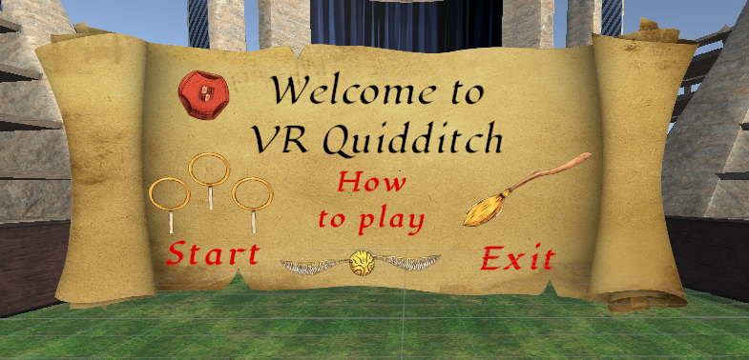

1. **Opening screen**:

“Start” – goes to “Game mode“ screen (multi or single player)

“How to play” - goes to “How to play” screen

“Exit”

2. **“Game mode” screen:**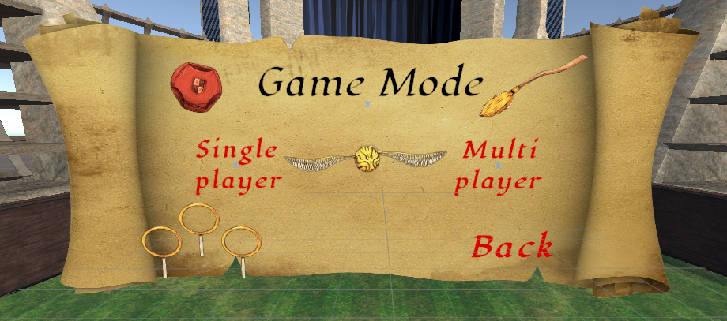

“One player” - goes to “Choose teams” screen.

“Two players” - goes to “Choose teams” screen.

“Back” – goes back to “Opening screen”.

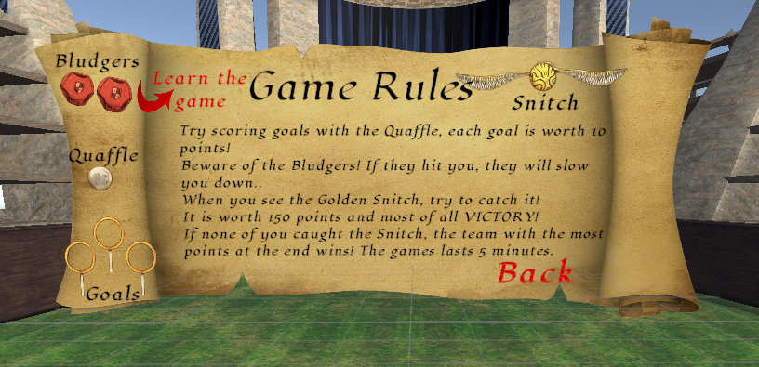

3. **“How to play” screen:**

Game rules.

“Learn the game” – goes to controller “Instructions” screen.

“Back” – goes back to “Opening screen”.

4.**”Instructions” screen:**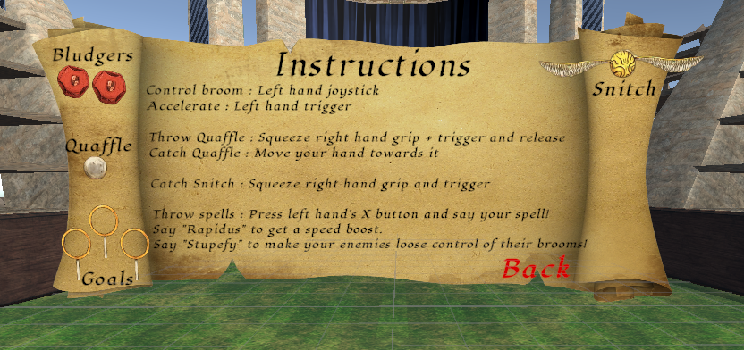

Instructions on the controllers.

“Back” – goes back to “How to play” screen.

5. **“Choose teams” screen**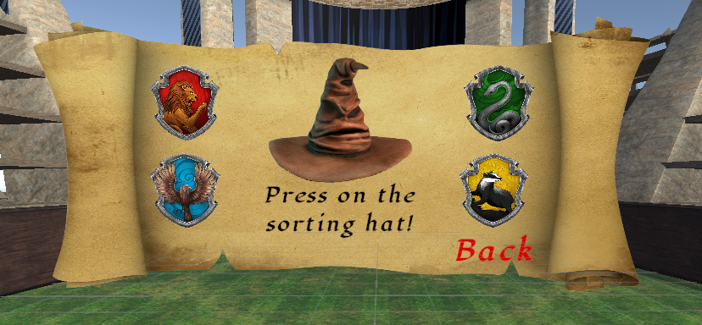

If there are two players, each one will see this screen.

“Back” – goes back to “Game mode” screen.

“Sorting hat” – goes to “Hat sorting” screen

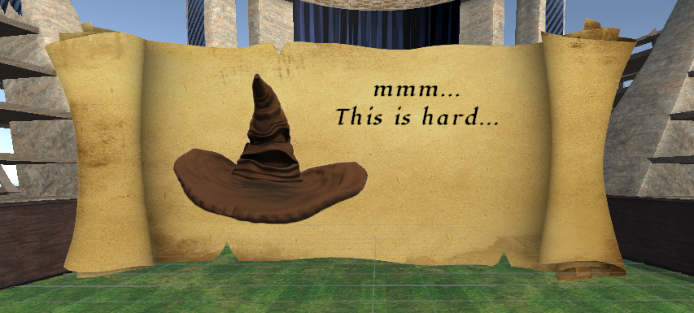

6. **“Hat sorting” screen**

Waits until both teams are ready and than goes to “Team reveal screen”

7. “**Team reveal” screen:**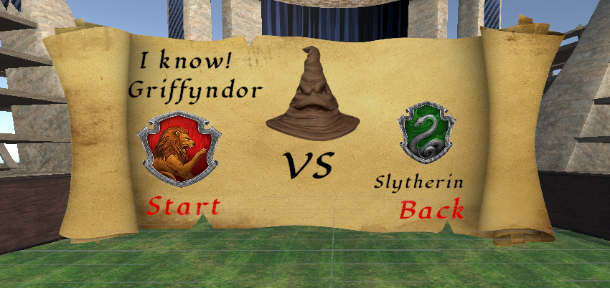

“Start” – brings you to the Match screen.

“Back” – goes back to “Game mode” screen.

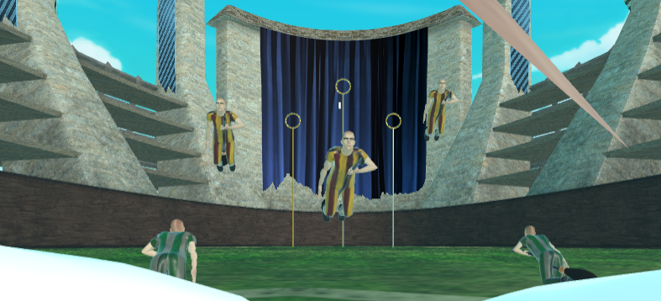

8. **Match screen:**

Timer icon – top left of the field.

Score icon - top right of the field.

Game stadium.

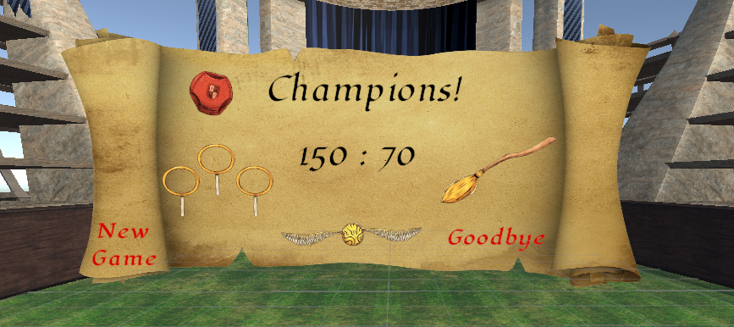

9. **Ending screen:**

Text according to victory or loss.

Shows Score.

“New game” – goes to “Opening screen”.

“Goodbye” – exits the game



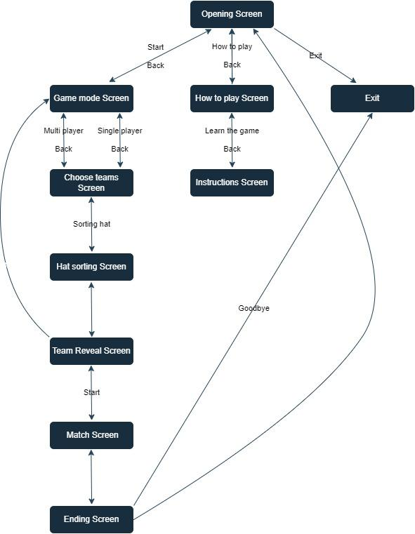

In the project, we implemented the XR Origin as the Virtual Reality (VR) interface, which served as the core foundation for our VR system.

This allowed for effortless interaction and communication with the virtual environment.

Utilizing XR Origin enabled users to effortlessly immerse themselves, manipulate objects, and actively participate in the immersive VR experience.

**Game controls:**

Left hand:

Controls broomstick fly movement using the **joystick**.

Acceleration is controlled with the **trigger**.

Right hand:

Catch and throw balls.

Catching Quaffle: When the right hand is within a certain range from the ball it catches it.

Throw Quaffle : Squeeze right hand **grip + trigger** and release

Catch Snitch : Squeeze right hand **grip + trigger**

Voice control:

The player uses voice commands by pressing on the **X button** on the left hand.

By pressing it and saying “**Rapidus**” the player gets a sudden speed boost faster for a brief moment.

By pressing it and saying “**Stupefy**” the opposite team will lose control of their brooms.

The commands are implemented using the Oculus SDK for Unity and Wit.ai.

**AI:**

The AI operates using the Finite State Machine (FSM) model, where each NPC (Non-Playable Character) functions as an individual machine.

The State Machine retains state and player data, including coordinates, status, team affiliation, role, and more.

It executes the logic associated with each state and updates the machine's next state accordingly.

For instance, if an enemy team member approaches the rings while holding the Quaffle (the ball), the Keeper will move forward to take possession of the Quaffle and then attempt to pass it to another teammate.

Once the "danger" dissipates, the Keeper will return to its original position of guarding the rings.

Since different player roles share certain states but follow distinct paths (for example, the Keeper transitions from Idle to Defend, while the Beater moves from Idle to Attack), we decided to incorporate the player's type into the States' logic.

This enables the AI to respond appropriately based on the player's role, determining when to advance with the ball, when to pass it, and when to attempt to score by throwing at the rings.

Chasers try to get close to the ball, if they do they can grab it and will get in position to take a shot at the goals, in which case the player can attempt to block it or let the Keeper try to.

[Keeper](https://en.wikipedia.org/wiki/Goalkeeper)s stick close to the goalposts and defend them, they can intercept incoming balls and pass them to chasers.

Beaters have bats and can hit “Bludgers” (hurtful metal balls) to redirect them.

Getting hit by a Bludger will slow down the player momentarily.

Seeker tries to catch the golden Snitch and bring victory to his team.

**Multiplayer:**

Multiplayer mode consists of duels between 2 players with each acting as the Seeker chasing the Snitch.

This is implemented with Photon PUN2, a free multiplayer connection management tool.

Photon allows us to use Unity physics for our movements and keep the game object transform (position, rotation, velocity...) synchronized without running local predictions while forcing updates from a server.   
This lets us run a relatively smooth player experience without making players VR-sick from the shaky movements. A player sets a lobby ID, while another uses that ID to connect and play together.  
AI, balls and other Game Objects are saved as prefabs with Photon script components to handle their spawning, despawning and synchronization.

**Integrating Wit.ai Voice Commands:**

By leveraging Wit.ai's voice recognition capabilities and Unity's VR tools, we enabled players to interact with the game using voice commands

Setting up Wit.ai Voice Commands

Creating Voice Commands:

Using Wit.ai, we trained the voice recognition model to recognize specific voice commands, such as "Rapidus" and "Stupefy" which are words we want to trigger the some actions in the game.

Defining Intents and Actions:

Within Wit.ai, we defined intents for each voice command, along with the corresponding actions that should occur in the game when the voice command is recognized.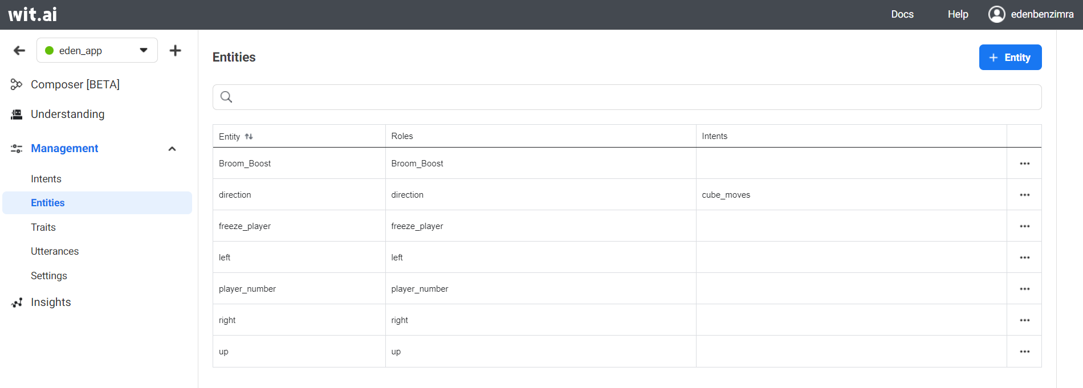

Integrating Wit.ai into Unity

Importing Wit.ai SDK:

To integrate Wit.ai into Unity, we imported the Wit.ai SDK into our project.

This SDK enables communication with the Wit.ai voice recognition service.

Configuring Wit.ai API:

We set up the necessary API credentials within Unity to allow the application to communicate with the Wit.ai servers for voice recognition.

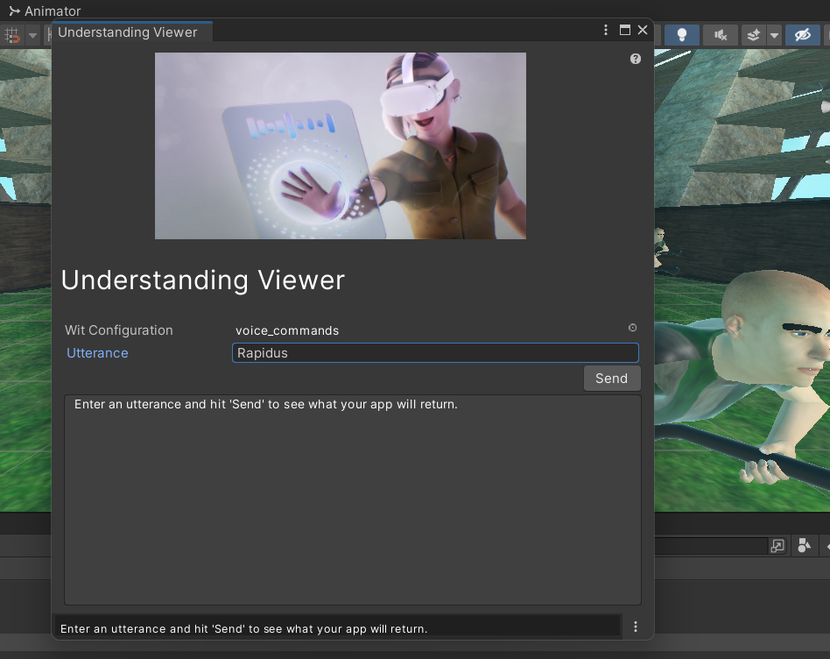

Implementing Voice Command Control in Unity

Voice Command Script:

We created a custom script in Unity to handle the voice command recognition.

This script used the Wit.ai SDK to listen for voice commands.

Voice Command Event:

Within the custom script, we set up an event that would be triggered when a recognized voice command matched one of the defined intents in Wit.ai.

VR Controller Interaction:

We attached the custom script to the VR controller, specifically the button (left hand "X") that would activate the voice command recognition when pressed.

Action Activation:

When the voice command was recognized and the corresponding intent was matched, the script triggered the desired action in the game, such as making the player's broom go faster.

**Creating a 3D Animation with Blender and Integrating it in Unity:**

We used Blender's 3D modeling tools to design and sculpt the AI characters.

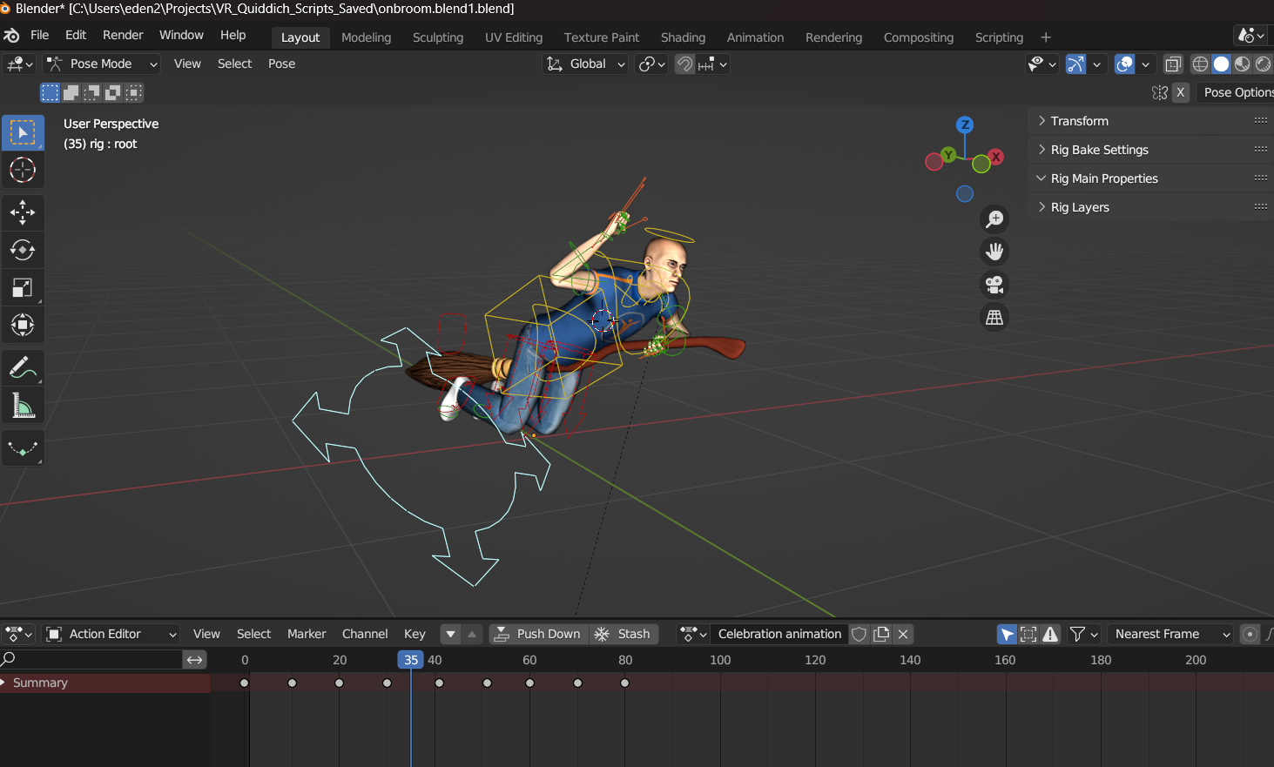

The rigging process consisted of creating a skeleton structure (armature) for the models, which enables it to move and interact realistically.

With the model rigged, we proceeded to animate it, using Blender's keyframe animation tools to create seamless and natural movements.

Finally, we rendered the animation into frames or video format using Blender's rendering engine, preparing it for integration into Unity.

In order to integrate it to Unity we exported the completed animation from Blender as an FBX

file allowed for compatibility with Unity.

Upon importing the animation into Unity, we used the Asset Importer to configure settings such as loop behavior and animation speed.

To manage the animation's playback, we created an Animation Controller in Unity, defining states and transitions for different animation sequences.

By attaching Animator components to game objects and connecting them to the Animation Controller, we could trigger animations during gameplay based on specific events or user interactions.

We also made a material out of colors of each team and used it to dress the character according to the assigned team.

Disappointment animation - attached to the team's loss event.

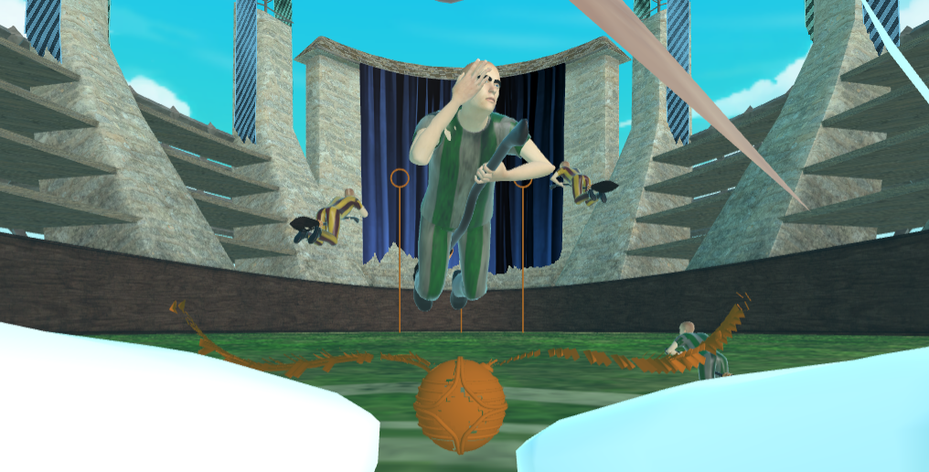

Celebration animation - attached to the team's victory event.

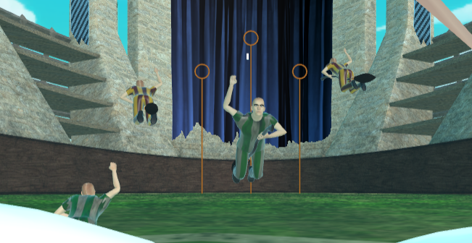

**Movement and Physics:**

The game relies on Unity’s built in mechanics to simulate physics and Photon PUN2 to synchronize them online. 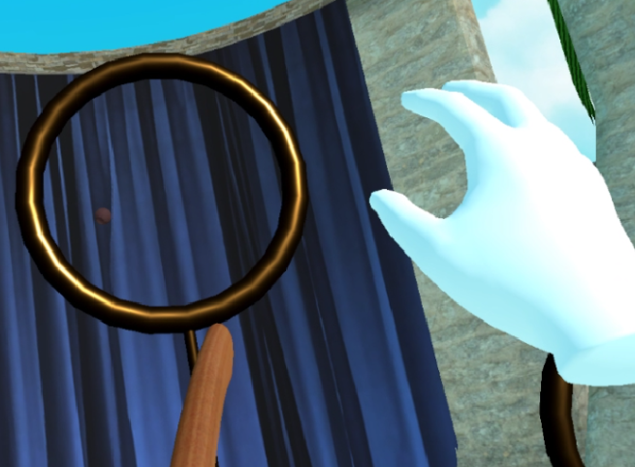

By using Unity’s XR grab interaction package we incorporated natural feeling interaction with objects. Scoring goals is achieved by actually picking up a ball and throwing it through the goalpost hoop, all handled by Unity physics.

The result feels natural to act out and aim as opposed to a scripted “shooting” of the ball.

Every VR control script taken from Unity’s XR kit has been reworked to fit the game. 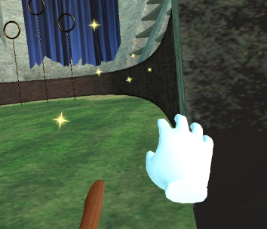

A custom movement script binds the player’s hand to a broomstick which acts as the forward source of the movement.

By pushing the joystick the player moves with respect to the front of the broomstick while squeezing the trigger provides an analog input that scales your speed up.   
The grab interaction script was remade to pick up objects from a distance: by calculating a dot product of the hand’s direction with the direction of the object, we can deem them alike enough to choose the correct object to pull. The Golden Snitch has a limited grab distance for balance reasons, but we wanted to be able to pull Quaffles to our hand so we can redo a bad throw before it’s too late, or pick it up from the ground without landing.

**Quidditch Equipment:**

The Golden Snitch runs a simple script to roam around the stadium, it starts out fast but slows down in relation to the game timer so it gets easy to catch after a few minutes, otherwise the best strategy would be to go for the snitch as soon as the game starts instead of scoring some points first.

Most of the Quaffles’ logic and handling comes from the VR experience of grabbing and throwing virtual objects.

Lost Quaffles will respawn and shoot up at the center of the stadium so the player doesn’t spend time looking for them in the bleachers.

A simple trigger box recognizes goals when you throw it through the hoop, added with some particle effects to show everyone when a goal is scored.

The Bludgers have their own AI with different states.

They will roam the arena and randomly choose players to harass.

If you successfully keep them at bay, they will give up and stop chasing you.

Their default behavior calculates the standard ellipse equation of the stadium to determine the next point to patrol around the edges.

Bludgers make howling wind noises to warn players, and when chasing a player they will play violent forest wind sounds with cracking branches to give the player an extra scare.

We decided slowing the player down is enough punishment for getting hit by a Bludger because stunning the player in place is not a fun gameplay mechanic and generally pretty disappointing, especially in VR.